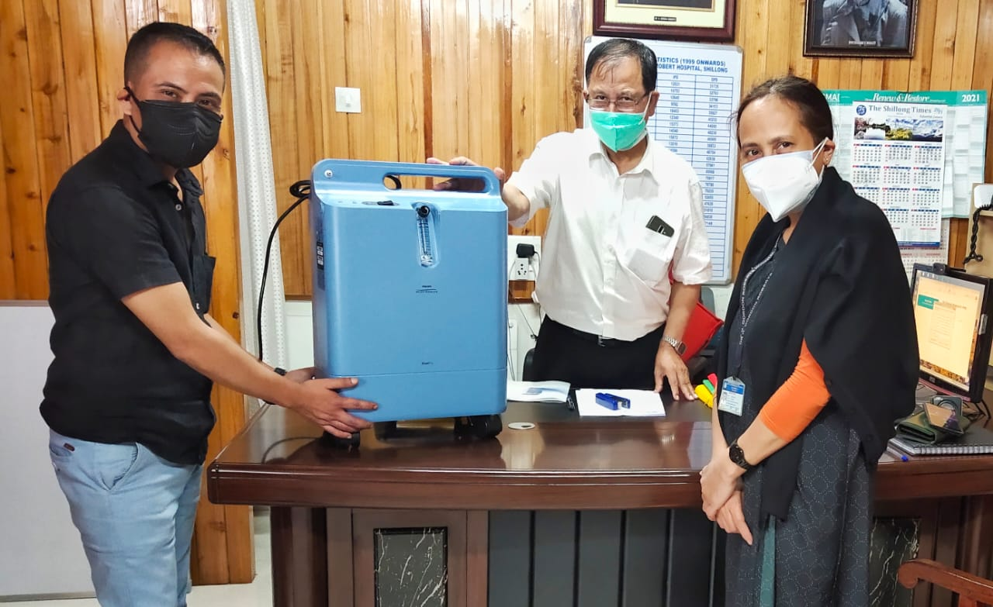
THE GENEROUS DONATION OF PHILIPS EVERFLO OXYGEN CONCENTRATOR BY ANA TIWARY AND HER FRIENDS, BASED IN AUSTRALIA (9TH JUNE 2021)
COURTESY: Mr KIT SHANGPLIANG

