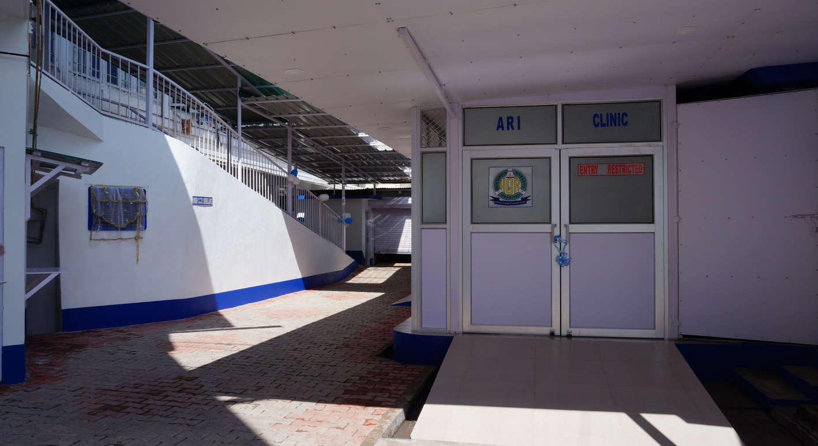

NEW ARI CLINIC AND THE NEW CONNECTING RAMP TO THE ARMALA ISOLATION WARD FOR COVID-19 PATIENTS.

.

